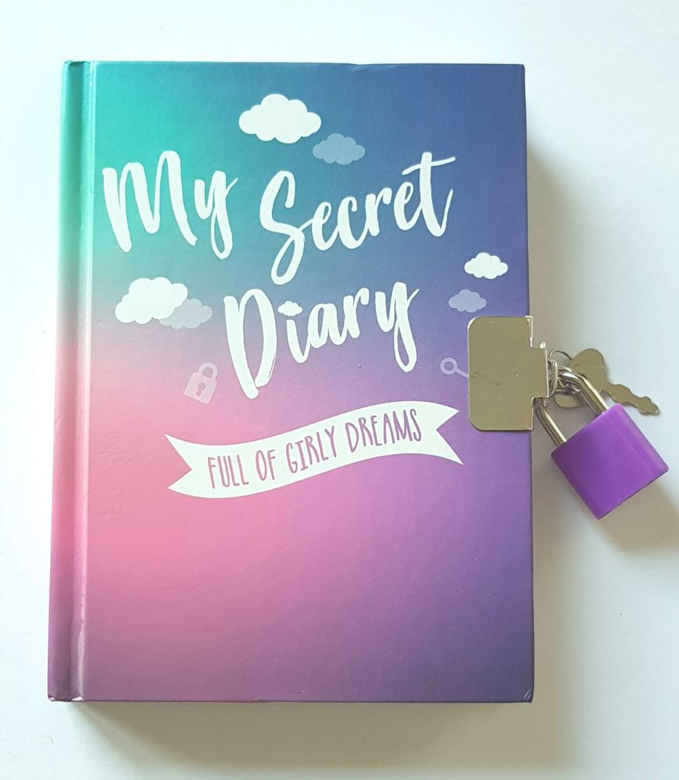

SECRET DIARY

RYANA CALENDARS is selling wonderful secret diaries in different colors and designs! It contains of great leather!

RS 990